**CTF Topic: Steganography Online**

**Introduction**

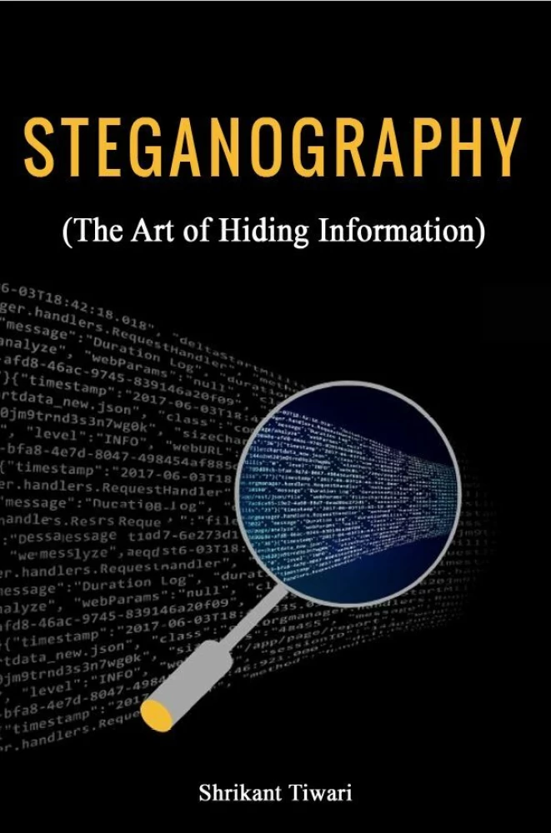

Steganography is the practice of hiding messages or information within other non-secret text or data. Unlike encryption, which only obscures the content of a message, steganography conceals the very existence of the message itself. This technique can be used to covertly transmit information without raising suspicion. Understanding how to use and detect steganography is crucial in fields such as digital forensics, cybersecurity, and data protection.

**Tools and Requirements**

Steganography Online:<https://www.mobilefish.com/services/steganography/steganography.php>

Scenario

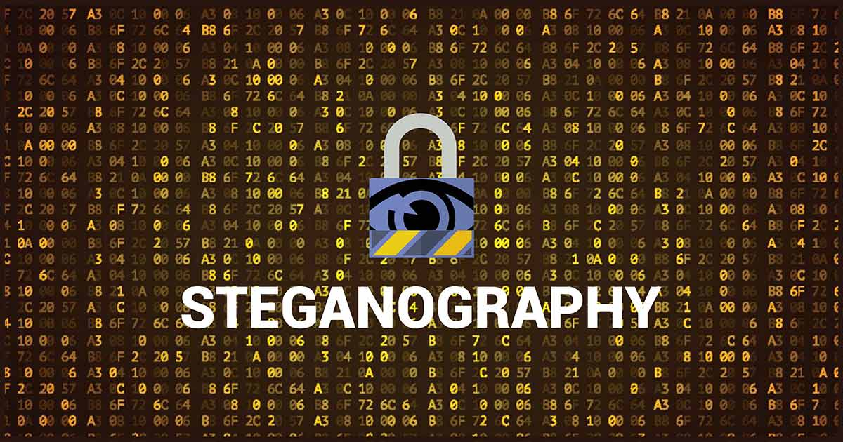

As a cybersecurity analyst, your task is to understand and test various steganography techniques using the provided web-based tool. This will help you learn how to hide and uncover hidden messages within images.

**Process to follow while performing CTF**

Step 1: To begin, navigate to the provided Steganography Online tool: <https://www.mobilefish.com/services/steganography/steganography.php>

Step 2: Download the image from this link [**https://ibb.co/BVBsc7C**](https://ibb.co/BVBsc7C)**.** To download the image click on the link it will redirect you to the image and right click and do save as.

Questions.

Flag 1: Decode the provided image with hidden text. What is the hidden message?

Answer: "Congratulations, you found the hidden message!"

Flag Captured.

**Hint**

